**Indiana University Southeast**

**2021-22 CSCI Capstone Project**

**Workshop Management Web Application**

**Sponsor: Dr. Suranga Hettiarachchi**

**Software Detailed Design**

**James Schlesener**

**Data Design**

The data for the Workshop Management System will be stored in a SQL database. The database will consist of three tables; one to store workshops, one to store participants, and one to store equipment. Each workshop can have multiple participants, and each participant can be assigned multiple pieces of equipment.

The SQL database will also have an users table to store the login information for the user’s of the software.

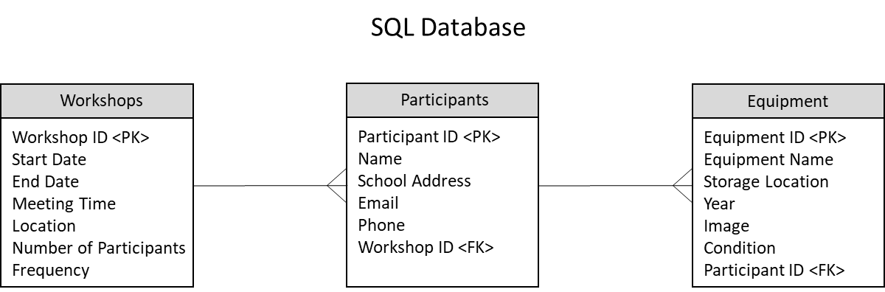

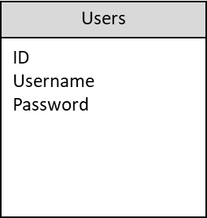

**Architecture Design**

The architecture consists of a front end client and a back end server. The user will use their web browser to interact with the web application. The web application will communicate with the server using HTTP. The server will respond to HTTP requests by storing data to and retrieving data from the SQL database.

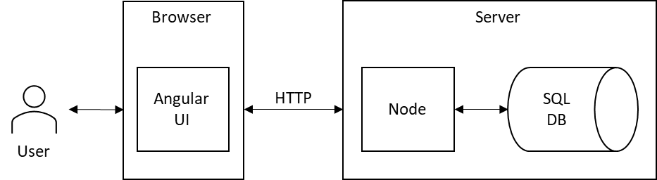

**Data Design**

The first user interface screen in the web application is a login screen. The user will enter their username and password to gain access to the system through an interface shown below.

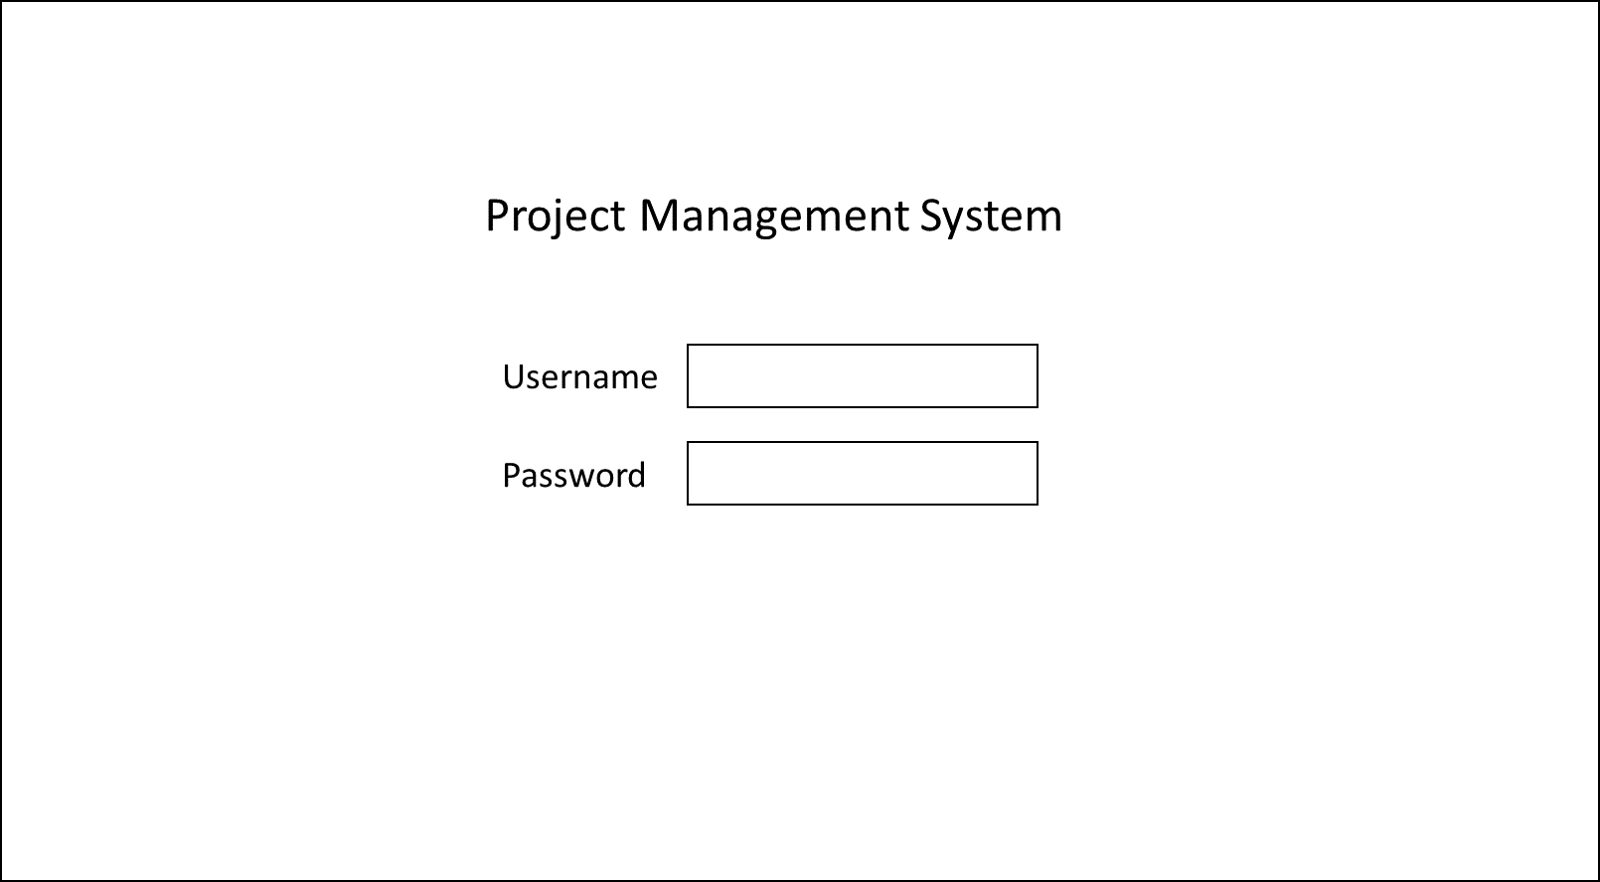

Once the user has logged into the system, the user will interact with the data using an interface such as the one shown below. On each screen within the web application, the user will always have a menu to access the list of workshops, list of participants, and list of equipment as well as the ability to logout of the system.

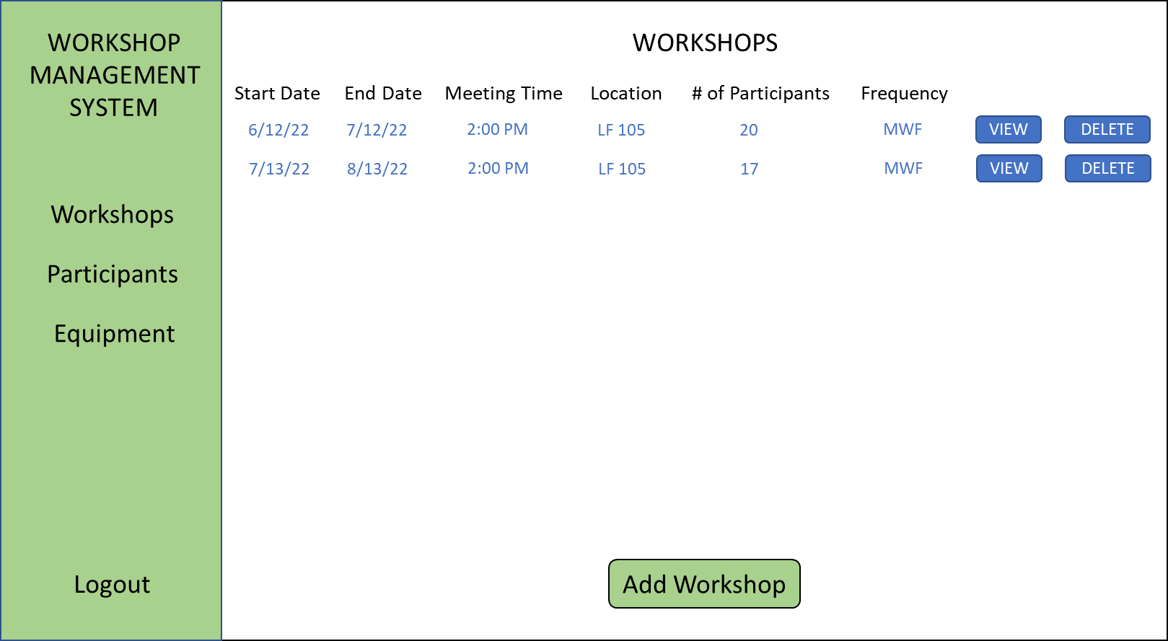

**Procedural Design**

The user begins at the login screen. Once the user has logged in, they are taken to the main screen where they can choose to list workshops, list participants, or list equipment. The main menu options and logout option are available on all screens.

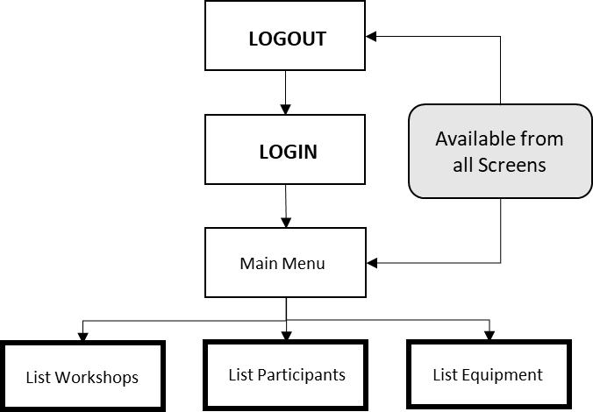

When the list workshops option is selected, it will show a list of all workshops including past and future dated workshops. On this screen, there will be an option to add a workshop. If workshops exist, there will be an option to delete a workshop and to view a workshop. The view workshop option will take the user to the view workshop screen.

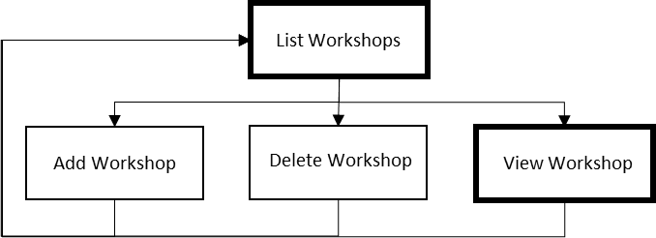

When the list participants option is selected, it will show a list of all participants both assigned and unassigned to workshops. On this screen, there will be an option to add a participant. If participants exist, there will be an option to delete a participant and to view a participant. The view participant option will take the user to the view participant screen.

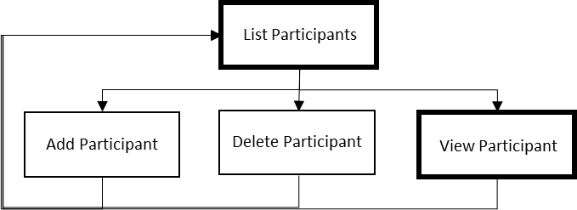

When the list equipment option is selected, it will show a list of all equipment both assigned and unassigned to participants. On this screen, there will be an option to add equipment. If equipment exists, there will be an option to delete equipment and to view equipment. The view equipment option will take the user to view equipment screen.



On the view workshop screen, the user can update a workshop, delete a participant if at least one exists, add a participant, or view a participant if at least one exists. If the view participant option is selected, it will take the user to the view participant screen.

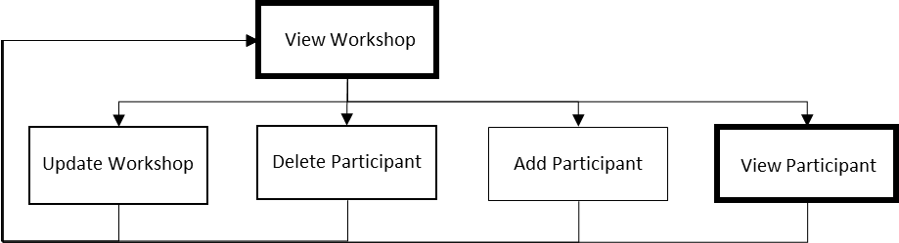

On the view participant screen, the user can update a participant, assign the participant to or unassign the participant from a workshop, assign the participant to or unassign the participant from equipment, or view equipment. If the view equipment option is selected, it will take the user to the view equipment screen.

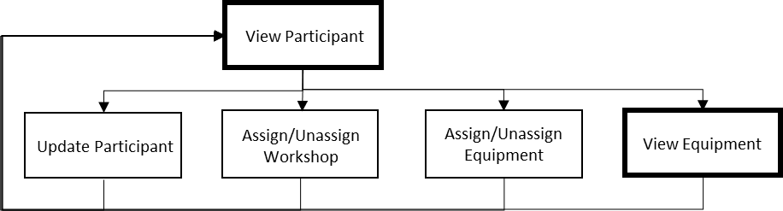

On the view equipment screen, the user can update equipment or assign/unassign equipment.

